Frequency Adjunct

✅ What Is a Frequency Adjunct?
# Source: AI Source: Provided by: [Data Path: Persons Table -> ID Column: 1, Name_En Column: Motasem Essam] -> From: [Chatgpt (GPT-4-turbo)] on [8/6/2025]
A frequency adjunct tells how often an action happens. It adds non-essential information about the repetition or regularity of the action in time.
It answers the question:
- How often?

🔸 Common Forms of Frequency Adjuncts:
# Source: AI Source: Provided by: [Data Path: Persons Table -> ID Column: 1, Name_En Column: Motasem Essam] -> From: [Chatgpt (GPT-4-turbo)] on [8/6/2025]
- Single-word Adverbs: always, usually, often, sometimes, rarely, never, occasionally, frequently
- Phrases: every day, once a week, from time to time, all the time, three times a year

🔸 Examples of Frequency Adjuncts in Sentences:
# Source: AI Source: Provided by: [Data Path: Persons Table -> ID Column: 1, Name_En Column: Motasem Essam] -> From: [Chatgpt (GPT-4-turbo)] on [8/6/2025]
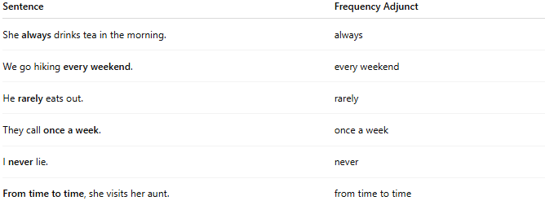
Sentence | Frequency Adjunct
She always drinks tea in the morning. | always
We go hiking every weekend. | every weekend
He rarely eats out. | rarely
They call once a week. | once a week
I never lie. | never
From time to time, she visits her aunt. | from time to time

🔸 Position in the Sentence:
# Source: AI Source: Provided by: [Data Path: Persons Table -> ID Column: 1, Name_En Column: Motasem Essam] -> From: [Chatgpt (GPT-4-turbo)] on [8/6/2025]
- Before the main verb: She often studies late.
- After the verb “be” (am/is/are): He is usually tired.
- Beginning or end: Sometimes he visits. / He visits sometimes.

🔸 Reminder:
# Source: AI Source: Provided by: [Data Path: Persons Table -> ID Column: 1, Name_En Column: Motasem Essam] -> From: [Chatgpt (GPT-4-turbo)] on [8/6/2025]
A frequency adjunct adds temporal regularity, but is not required for the sentence to be grammatically correct.
🟢 "He calls."
🟡 "He calls once a week." → Frequency adjunct adds detail

